SIMATS ENGINEERING
ASSESSMENT TOOL 2

COURSE NAME: INTERNET PROGRAMMING
COURSE CODE: CSA43

COURSE OUTCOME COVERED

CO-1: Develop well-structured, standards-compliant web pages using HTML/XHTML and XML, and apply Internet protocols and HTTP communication mechanisms for web content delivery. (L2)

Assessment Tool : Data Interpretation

Weightage: 20%

QUESTIONS: Total Marks: 20

1: HTTP Response Analysis
A web server returns the following HTTP response header:
HTTP/1.1 200 OK
Date: Mon, 01 Apr 2026 10:00:00 GMT
Content-Type: text/html
Content-Length: -150
Connection: keep-alive
Questions:
- Identify any incorrect or invalid fields in the header.
Content-Length: -150 is invalid because Content-Length cannot be negative.

- Analyze the issue with Content-Length and explain its impact.
A negative value (-150) is invalid. It may cause:
Incorrect response processing.
Browser errors.

- Determine whether the status code matches the response correctness.
No.
The status code 200 OK indicates that the request was successful.

- Suggest corrections for the identified errors.
HTTP/1.1 200 OK
Date: Mon, 01 Apr 2026 10:00:00 GMT
Content-Type: text/html
Content-Length: 150
Connection: keep-alive

2: DOM Structure Analysis
Consider the following DOM tree representation:
<html>
<head>
<title>Test Page</title>
</head>
<body>
<div>
<p>Hello World
</div>
</body>
</html>
Questions:
- Identify missing or improperly closed elements.
The <p> tag is missing its closing </p> tag.

- Analyze how the browser will interpret this structure.
Modern browsers will usually automatically close the <p> element when necessary and create a corrected DOM structure.
- Determine the impact on rendering and layout.
The text "Hello World" will usually display normally. However, improper HTML structure can cause unexpected layout or CSS styling issues, especially when more elements are added.

- Suggest corrections to make the DOM valid.
<!DOCTYPE html>
<html lang="en">
<head>
<meta charset="UTF-8">
<title>Test Page</title>
</head>
<body>
<div>
<p>Hello World</p>
</div>
</body>
</html>

3: GET vs POST in Login System
A login system uses two different methods:
Method | URL Example | Data Visibility | Security Level
GET | /login?user=admin&pass=1234 | Visible in URL | Low
POST | /login | Hidden in body | Moderate
Questions:
- Interpret the differences in data transmission between GET and POST.
GET: Sends data through the URL, so the data is visible.
POST: Sends data in the request body, so it is not displayed in the URL.

- Analyze which method is more suitable for login and why.
POST is more suitable for login because usernames and passwords are not exposed in the URL. It should always be used with HTTPS for secure transmission.

- Identify security risks in using GET for authentication.
Username and password are visible in the URL.

- Suggest best practices for secure login implementation.
Use POST for login forms.
Always use HTTPS.

4: HTML Code Inspection
Analyze the following HTML snippet:
<!DOCTYPE html>
<html>
<head>
<title>Sample</title>
</head>
<body>
<h1>Welcome
<p>This is a paragraph
<img src="image.jpg">
</body>
</html>
Questions:
- Identify missing closing tags.
The <h1> tag is missing </h1>.
The <p> tag is missing </p>.

- Analyze issues with the <img> tag.
<img src="image.jpg" alt="Sample Image">

- Determine how browsers will handle these errors.
Modern browsers usually try to automatically correct missing closing tags and display the page. However, these errors may cause unexpected layout or styling issues.

- Suggest a corrected version of the code.
<!DOCTYPE html>
<html lang="en">
<head>
<meta charset="UTF-8">
<meta name="viewport" content="width=device-width, initial-scale=1.0">
<title>Sample</title>
</head>
<body>

<h1>Welcome</h1>
<p>This is a paragraph</p>
<img src="image.jpg" alt="Sample Image">

</body>
</html>

Output:
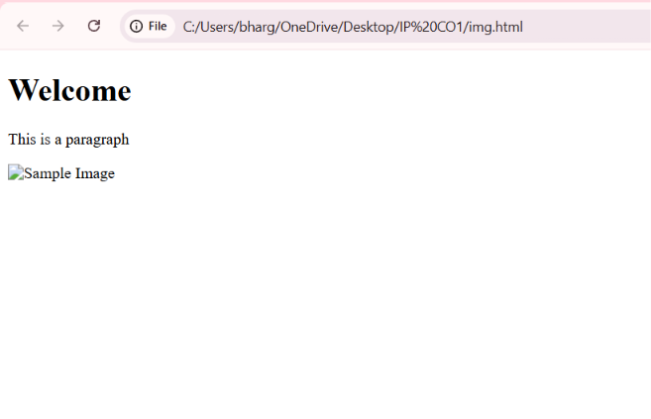

5: Browser-Server Communication Flow
The following sequence describes a web request:
- User enters a URL in the browser
- DNS lookup occurs
- HTTP request is sent
- Server processes request
- Response is returned
- Browser renders page
Questions:
- Interpret each step in the communication flow.
User enters URL: The user types a website address in the browser.

DNS lookup: DNS converts the domain name into an IP address.

HTTP request: The browser sends an HTTP/HTTPS request to the server.

Server processes request: The server receives and processes the request.

Response returned: The server sends the requested data back to the browser.

Browser renders page: The browser processes HTML, CSS, and JavaScript and displays the webpage.
- Identify where delays can occur.
Delays may occur during:
DNS lookup.
Network connection.

- Analyze the role of DNS in the process.
DNS converts a human-readable domain name, such as example.com, into an IP address that allows the browser to locate and connect to the correct server

- Suggest optimizations to improve performance.
Use DNS caching.
Use browser caching.

Code of Conduct:

I __Ch.Bhargav Ram_(192425334)_ (Name / Reg No) certify that this submission is my original work and that I have adhered to the guidelines specified for this assessment.
I understand that any violation of academic integrity rules will result in disciplinary action.

Signature of the student:

RUBRICS FOR CALCULATION:

Criteria | Weightage | Level 4 (Exemplary) | Level 3 (Proficient) | Level 2 (Developing) | Level 1 (Beginning)
Understanding of Data | 25% | Accurately interprets all data patterns, trends, and relationships | Interprets data correctly with minor gaps | Partial understanding; misses key trends | Misinterprets or fails to understand data
Analysis | 25% | Provides deep analysis with strong logical reasoning and justification | Provides reasonable analysis with some justification | Basic analysis with weak reasoning | No meaningful analysis provided
Application of Concepts | 20% | Effectively applies relevant concepts/tools to interpret data accurately | Applies concepts with minor errors | Limited application; requires guidance | Unable to apply concepts to data
Conclusion | 20% | Draws clear, meaningful conclusions with strong insights and implications | Provides valid conclusions with moderate insights | Conclusions are vague or weak | No clear or valid conclusions
Clarity | 10% | Presents interpretation clearly using proper structure, visuals, and terminology | Generally clear with minor issues | Lacks clarity or proper structure | Poor presentation and difficult to understand

